StudioFlow
Milestone 1 — Documentation and Problem Solution
MOD8 — Advanced Web Programming
Team: Raphaël, Théodore, Guillaume
Repository: github.com/ElpharienPY/StudioFlow
1. Problem Statement & Proposed Solution
2. Entity-Relationship Diagram
3. Initial Front-End Design Mockups
4. Project Plan

1. Problem Statement & Proposed Solution
The problem
Most of us have been part of a small content team at some point, whether it's a school club's YouTube channel, a friend group doing TikTok edits, or a freelance gig cutting videos for a client, and the same thing always happens: the actual production process lives nowhere. One person tracks deadlines in a Notion page, another keeps the shot list in a group chat, and the "final" cut ends up being version 4 of a file called final_v2_REAL.mp4 sitting in someone's Google Drive.
Generic task managers like Trello or Notion can technically be bent into shape for this, but they don't understand what a video actually goes through. A task being "In Progress" doesn't tell you whether it's still in scripting or already being edited, and there's no real place to attach the footage, the script draft, and the client's feedback to the same deliverable. On the other end, actual production-pipeline tools exist, but they're built (and priced) for real studios, not a team of three or four people managing a handful of videos.
So teams end up stitching together three or four tools that don't talk to each other, and the person who suffers the most is whoever is trying to figure out, at a glance, what's actually left to do before a video goes live.
Our solution
StudioFlow is a small web app built specifically around how a video (or any short-form content piece) actually moves from idea to publish. It keeps the simple To Do / Doing / Done board everyone already understands, but layers a second, content-specific dimension on top of it: every task also carries a production stage (concept, script, shooting, editing, thumbnail, publishing), so the board tells you not just what's left, but where things really are in the process.
Concretely, the app is organized around a few ideas that map directly onto our data model:
- A project groups everything related to one client, campaign, or channel.
- Each project is broken down into deliverables, one per actual video or post, with its own platform, publish date, and revision count.
- Each deliverable has tasks on the kanban board, and each task can carry comments, so feedback from a teammate (or a client) stays attached to the thing it's about instead of getting buried in a chat history.
- Assets (scripts, raw footage, cuts, thumbnails) are tracked with a version number per deliverable, so "which file is the latest one" stops being a recurring question.
Since this is still a shared tool with client work potentially involved, access matters: accounts are protected with hashed passwords and token-based sessions (with an optional "Sign in with Google" for convenience), and each project member has a role (owner, editor, or viewer) so a client can be given visibility without editing rights.
Scope for this project
For this course we're building StudioFlow with Vue.js on the front-end, Node.js on the back-end, and MySQL for storage. We're deliberately keeping the first version focused on the core loop: create a project, break it into deliverables and tasks, move tasks across the board, rather than trying to match everything a commercial pipeline tool does. Features like notifications, file uploads (assets are stored as links for now), or calendar views are things we'd consider later, but they're out of scope for the three milestones of this course.

2. Entity-Relationship Diagram
The schema below covers authentication (users, OAuth accounts, refresh tokens), project membership and roles, deliverables and their production assets, and the task/comment system behind the kanban board. It was modeled in DBML and exported from dbdiagram.io.
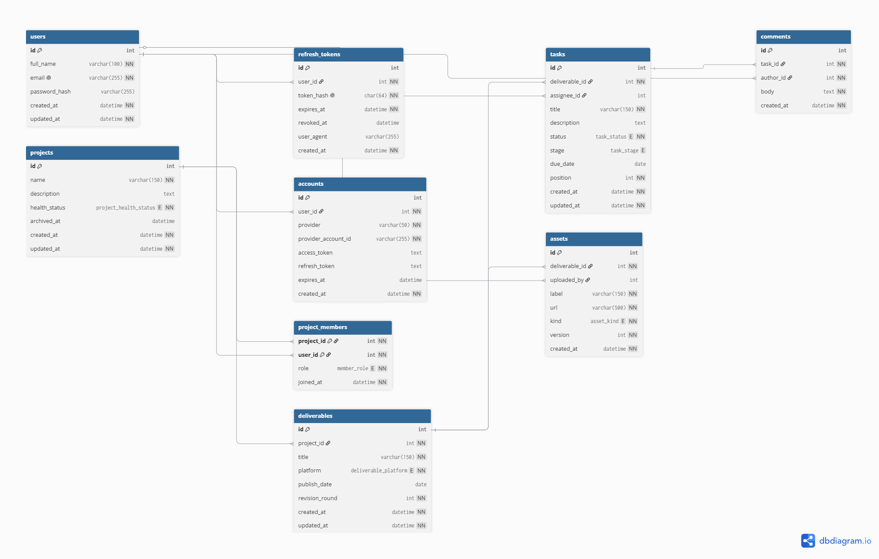
Figure 1 — StudioFlow entity-relationship diagram (8 tables + accounts)

3. Initial Front-End Design Mockups
Early mockups for the core screens, designed with the help of Claude Design and reviewed against the schema above to make sure every field shown on screen actually exists in the database (and vice versa).
Note: the logo shown on the sign-in screen is a temporary placeholder, not the final version. We're still designing the actual StudioFlow logo by hand and will swap it in before Milestone 2.
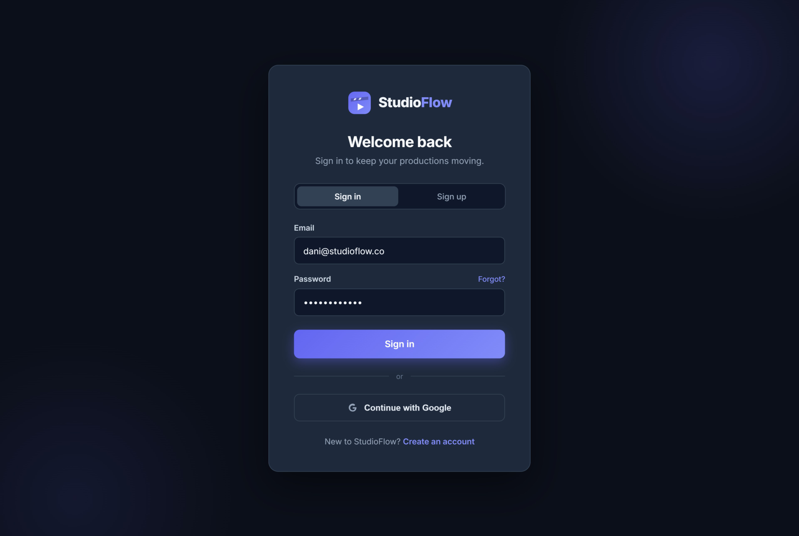
Sign in
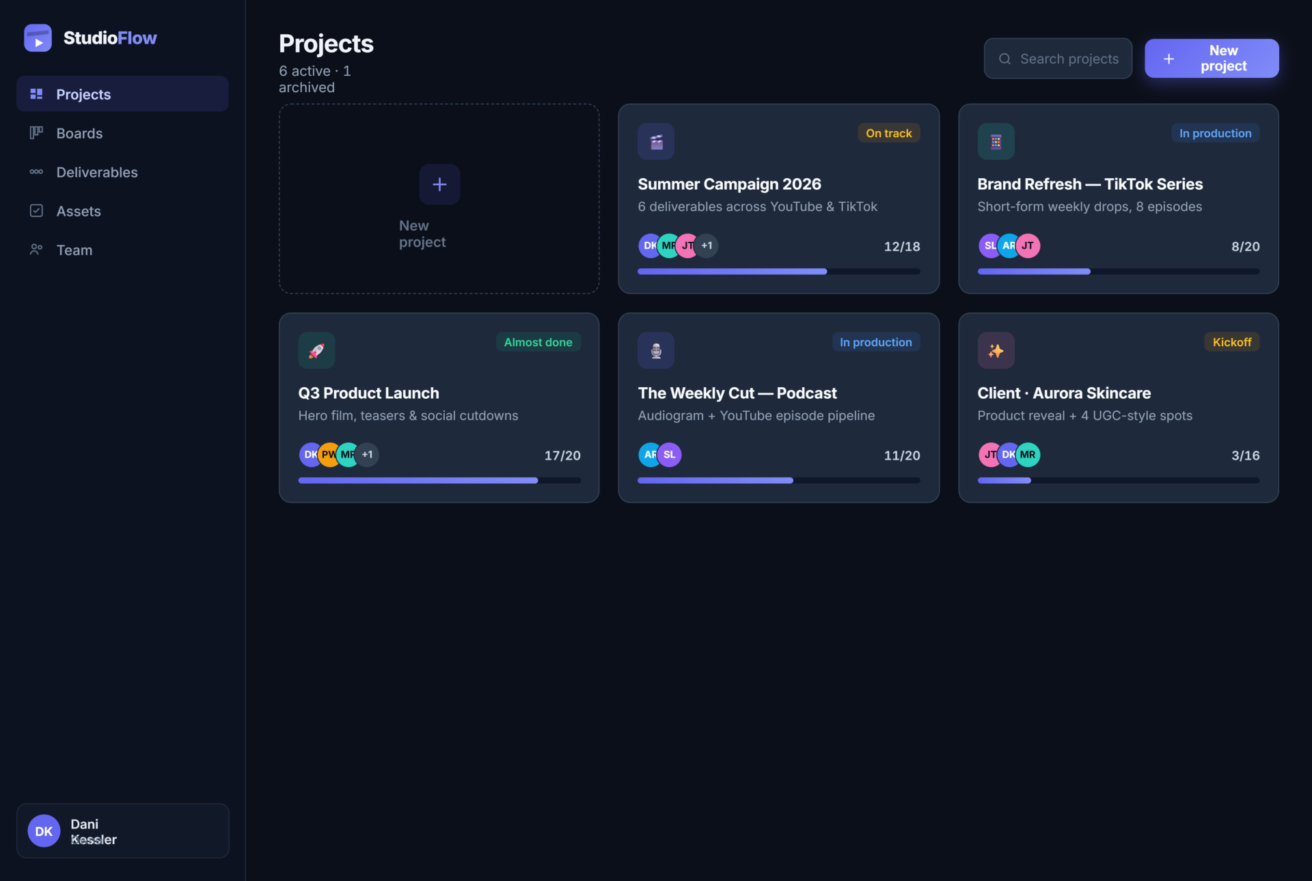
Projects dashboard
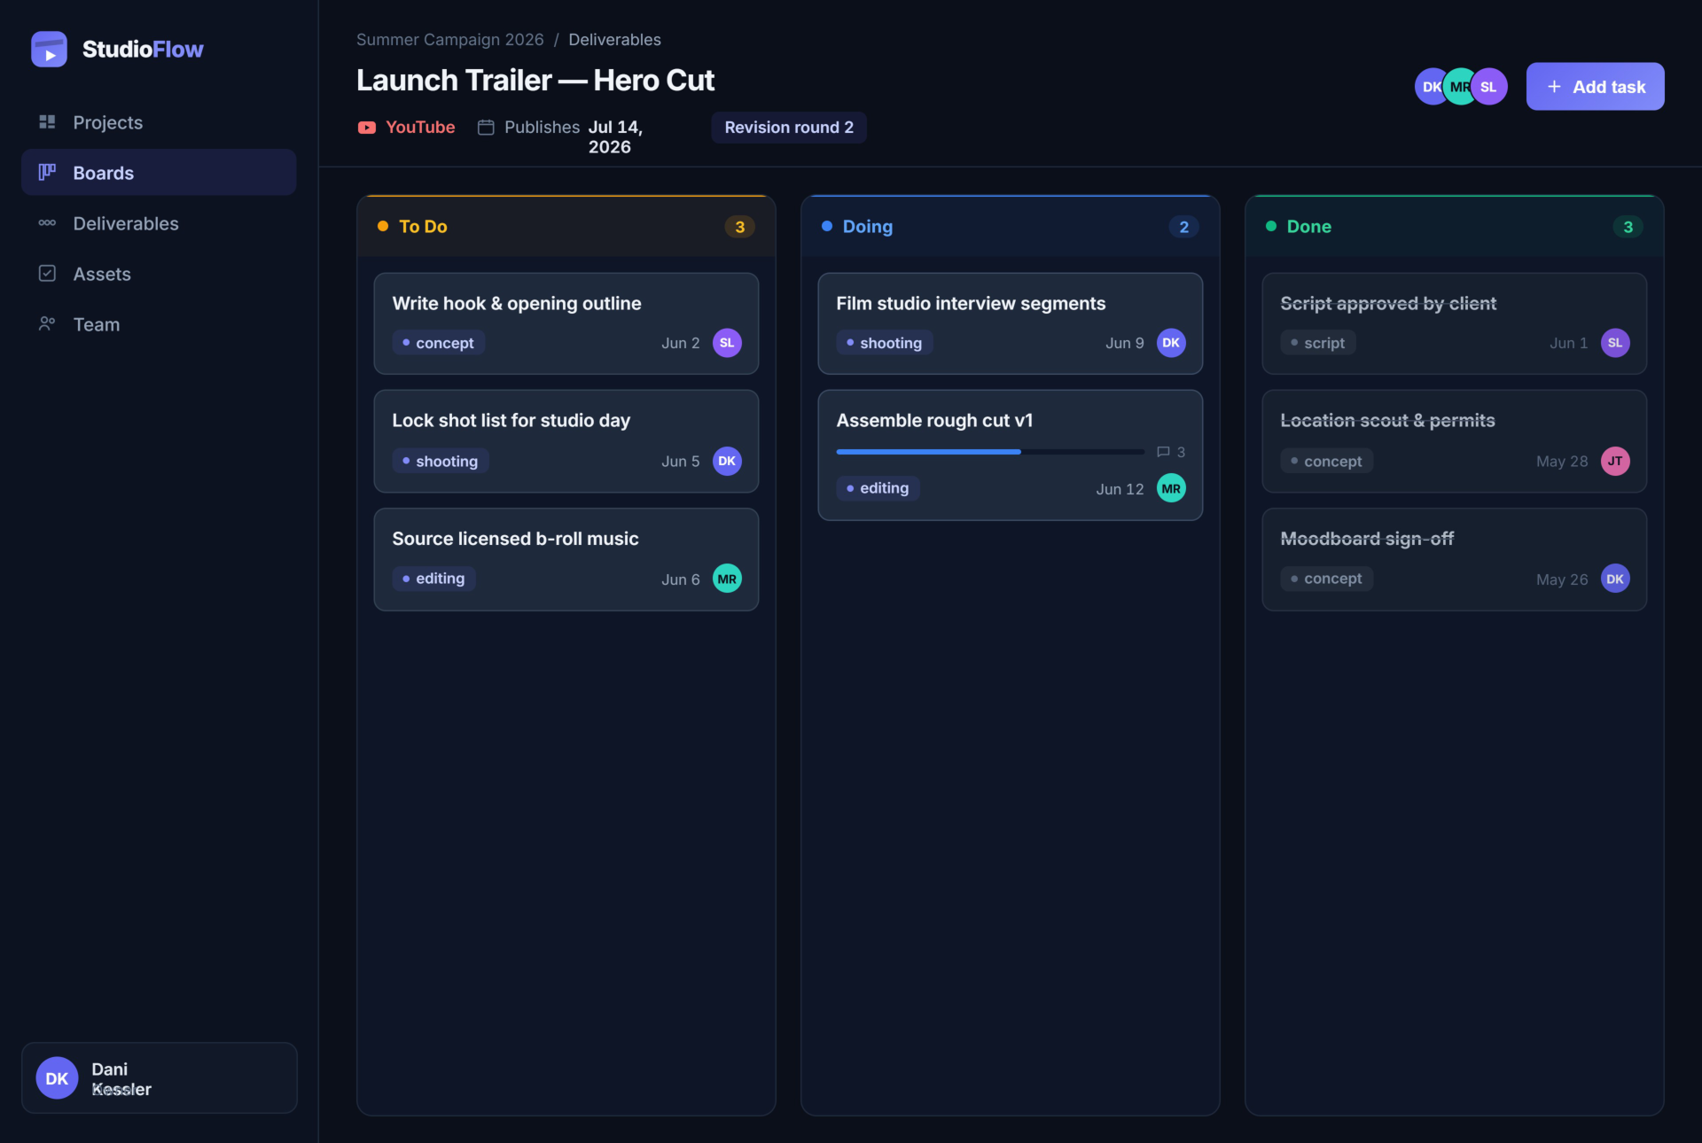
Kanban board — Launch Trailer
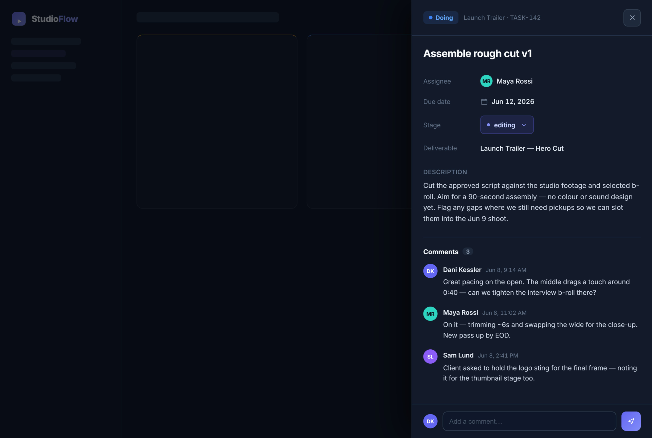
Task detail panel
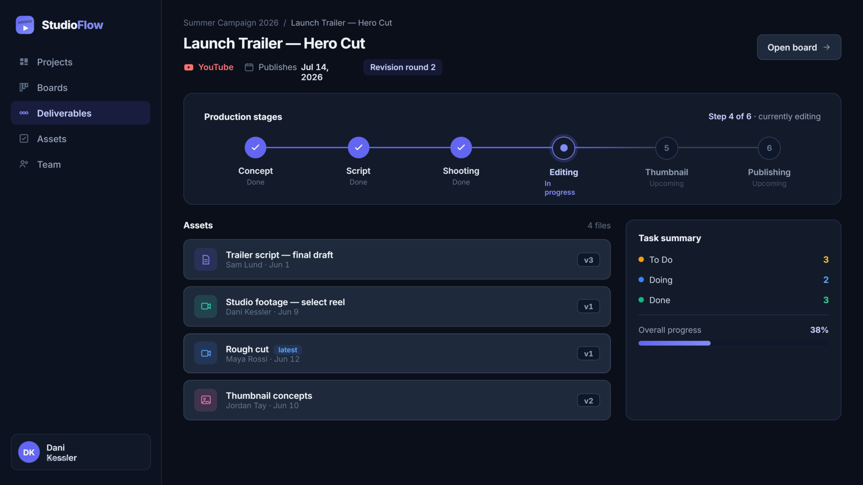
Deliverable overview & production stages

4. Project Plan
Team and task distribution
We split the work by feature vertical, aligned with the database tables, so each person owns their slice end to end, from the front-end in Milestone 2 to the back-end in Milestone 3.
Person | Vertical | Scope | Tables
Raphaël | Auth & Team | Sign up / sign in, token sessions, Google sign-in, member roles | users, accounts, refresh_tokens, project_members
Théodore | Boards & Tasks | Kanban board, task detail, comments | tasks, comments
Guillaume | Projects & Deliverables | Projects dashboard, deliverable view | projects, deliverables, assets

Timeline
These are rough target dates, not hard commitments. We're three students juggling this alongside the rest of our course load, so treat everything below as "around this week" rather than a fixed deadline.
Step | Target | Content
Milestone 1 | ~ early Oct 2026 | Problem statement, ERD, mockups, project plan
Front-end — auth & app skeleton | ~ mid Oct 2026 | Vue.js layout, routing, static screens
Front-end — vertical integration | ~ early Nov 2026 | Dynamic components per vertical
Milestone 2 | ~ mid Nov 2026 | Complete front-end on GitHub
Back-end — API + DB per vertical | ~ late Nov 2026 | Node.js routes, MySQL queries per vertical
Front/back integration + testing | ~ early Dec 2026 | Full wiring, bug fixes
Milestone 3 | ~ mid Dec 2026 | Complete back-end, presentation (5–7 min)

Notes
- Auth & Team is the most complex vertical (security, tokens, OAuth) and blocks the other two for end-to-end testing, so it starts first.
- A deliverable's current production stage (shown in the mockups) is computed from its tasks rather than stored directly, to avoid duplicated, inconsistent data.
Note: this document was put together with the help of Claude Code, which pulled together the schema, ERD, mockups, and project plan already tracked in our GitHub repository (github.com/ElpharienPY/StudioFlow) into this single file.

